**Hands-On Lab/Demo Script**

**Java Development on Linux with Visual Studio Team Services**

# Exercise 4: Running Maven builds, Unit Tests and Code Coverage with VSTS

Lab version: 1.1.0

Last updated: 3/7/2016

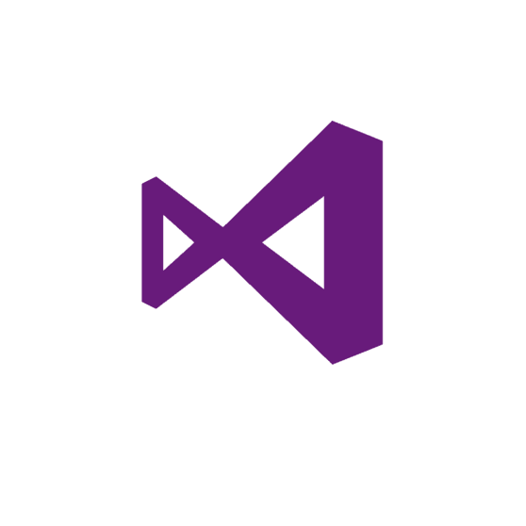

## Building your Java project with Maven

In this exercise, you will learn how to create a Team Build that runs in Visual Studio Team Services. This makes it quick and easy to start building your code, either manually or in an automated fashion, without having to worry about any build server configuration.

### Creating a new build definition

1. To the right of the master branch, click the **setup now** button.

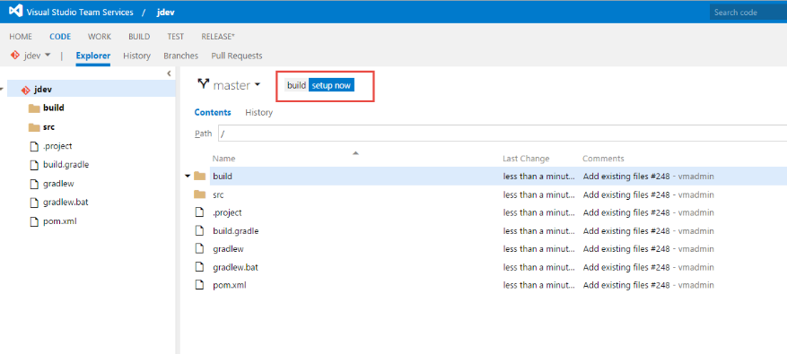

1. In the **Create a new build definition** dialog, select the **Empty** definition at the bottom and click **Next.**

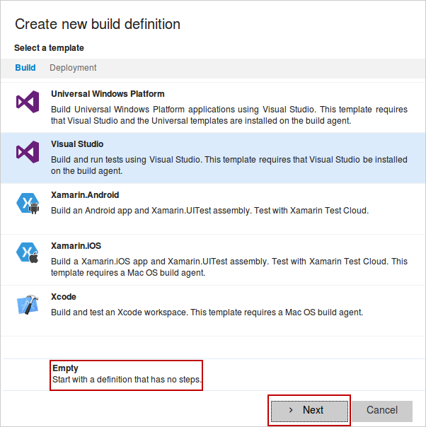

1. On the next page, you’ll see you can configure repo and branch settings. Accept the defaults and click **Create**.

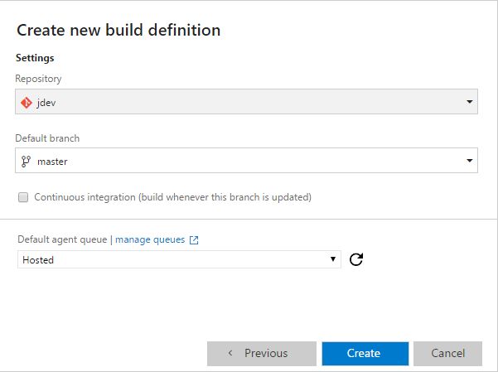

Visual Studio Team Services creates the new empty build definition and opens a new browser tab in the Build hub where you can continue editing the build.

1. Click the **Add build step** button.

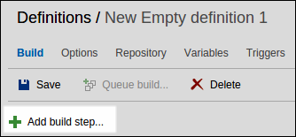

1. In the Add Tasks dialog, scroll the list of **Build** tasks and select the **Maven** build task and click **Add**.

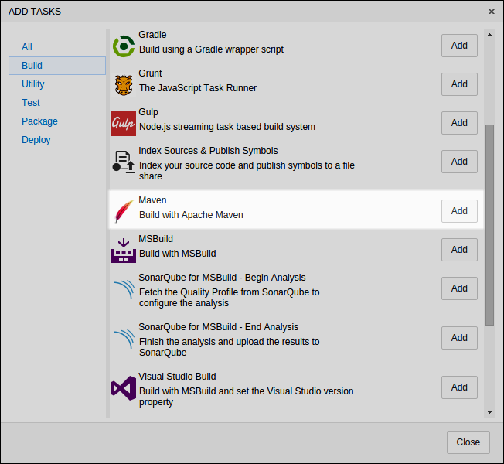

1. Click **Close**.
2. Click the **…** button at far right of the **Maven POM file** option.

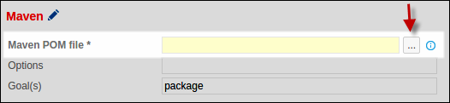

1. In the Select Path dialog, select the **pom.xml** file and click **OK**.

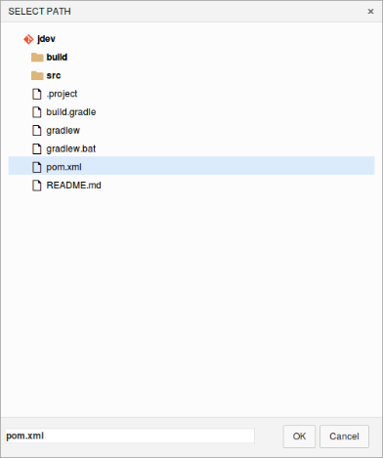

1. Click **Add build step**.

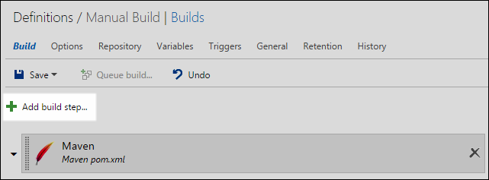

1. First click the **Utility** link.
2. Next click **Add** for the **Copy and Publish Build Artifacts** task.

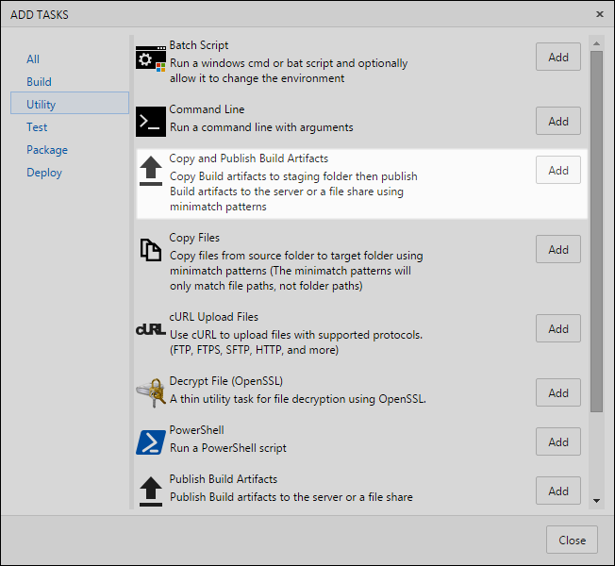

1. Close the **Add Tasks** dialog.
2. Select the Copy and Publish Build Artifacts build step.
3. Edit the settings to look as follows:

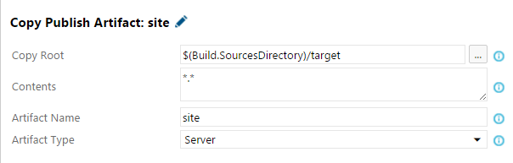

1. Click the **Save** button to save your build definition.

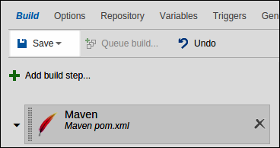

1. In the SAVE dialog type **Manual Build** for the **Name**.
2. In the **Comment** field, enter **Initial definition using Maven**. A great feature of builds is that VSTS versions your build definitions so you can see when and why a change was made and once you have two or more, you can diff the JSON-based definition. Click **OK**.

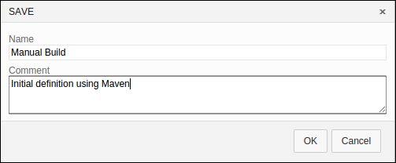

1. Click the **Queue build** button to start a build. Right now you’ll use the hosted build service in the Azure cloud.

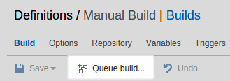

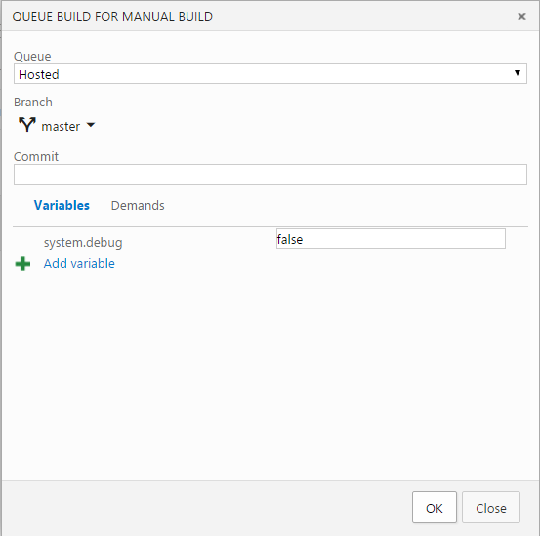

1. Click **OK** to queue the build.

VS Team Services with queue the build and keep you posted on its progress.

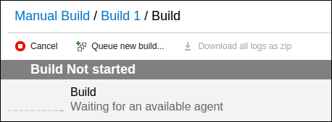

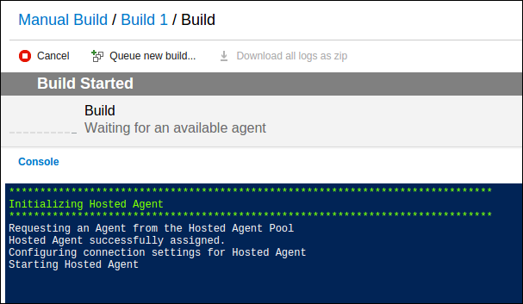

1. Monitor the build until it completes. It will take a couple of minutes. You can monitor the progress in the Console window.

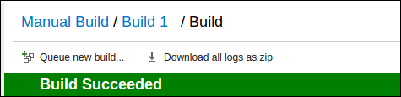

1. Once it’s done, you examine the build details by click the “Build #” link where # is the build run number (in the preceding screen shot it’s a 1).
2. The build report will tell you lots of details including related commits, associated work items, and unit test results.

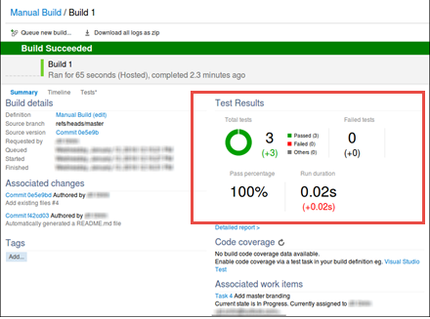

### Running Unit Tests

1. Notice the **Test Results**. The unit tests were executed as a part of the Build and the test results are published back to VSTS since by default, the **Publish to VSTS/TFS** option is checked

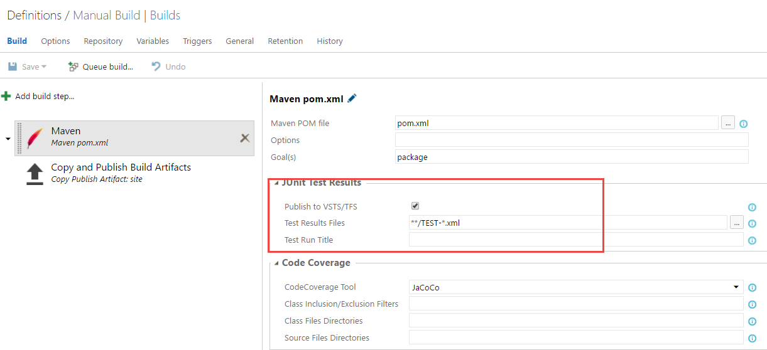

1. Selecting the **Detailed Report** in the **Test Results** section will take you to the **Tests** tab on the Build Results page. Here, you can see

* Aggregate summary for total tests, failed tests, pass percentage and test duration, giving you a consolidated status across all test runs.
* Break up of test failures into ‘New’ and ‘Existing’ failures. New failures are tests that were passing in previous build but are failing in the current build. These will help you identify regressions introduced in the current build.

By default, the **Outcome** filter is set to ***failed***showing only test cases that failed. Changing the filter to ***all*** will show all test cases.

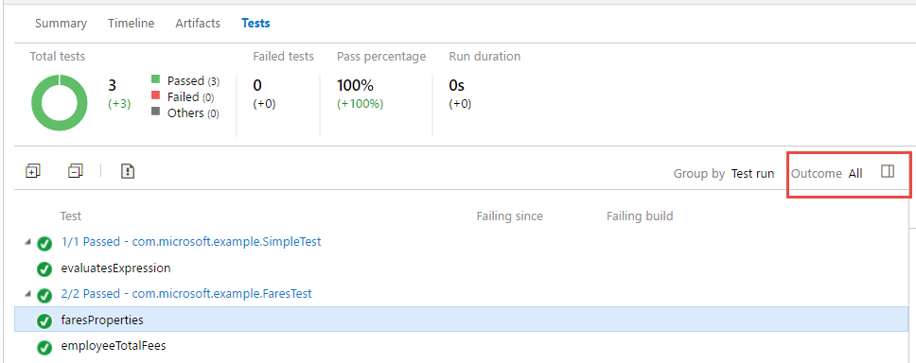

**Note**: For failed tests, the details pane will show the error message and the stack trace to help you investigate the cause of the failure. The graph above the details pane will show the outcome trend of the tests that can help you quickly identify if the tests fail intermittently.

You can also file a new bug (or associate an existing bug) for failed tests. When you file a new bug, the bug work item will be auto-populated with information like error and stack of the failing test.

### Enabling Code Coverage

Teams use code coverage data to measure the effectiveness of the test and identify the parts of the source code that are not tested or executed. With VSTS, enabling code coverage is a simple task. You only need to specify what tool you want to use for running code coverage. Currently, VSTS supports **Jacoco** and **Cobetura** for Java projects.

* [**Jacoco**](http://eclemma.org/jacoco/) is an open source tool for measuring and reporting Java code coverage. It provides coverage analysis of instructions, branches, lines, classes, methods, types and yclomatic complexity.
* [**Cobetura**](http://cobertura.github.io/cobertura/) is an another free Java tool that calculates the percentage of code accessed by tests. It measures branch and line coverage .

Note that if you are using **hosted** agent for your build, Jacoco and Cobetura add-ins will be pulled automatically by the agent. You will just need to select the tool you want to use for code coverage!

If you use other local private agents, you will need to manage this yourself by adding the plug-ins to your maven file.

1. Let’s add code coverage to our Build definition now. Modify your build definition and select **Jacoco** as the code coverage tool. Note that for **Options** in the Maven section, we have specified the tests that we want to run. If you want to run all the tests, you can simply omit this parameter.

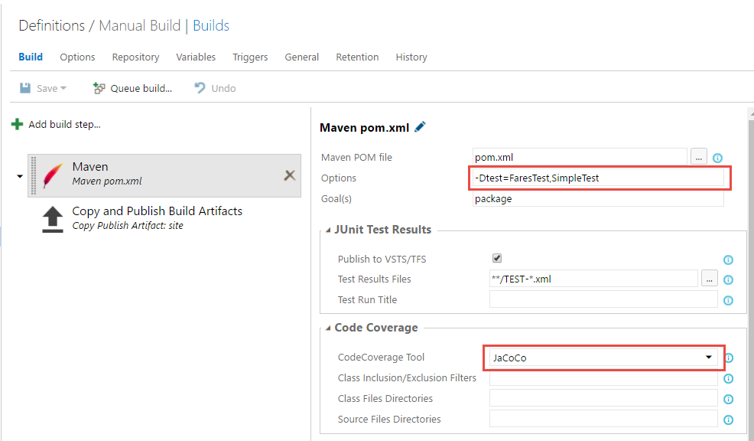

1. Save the build definition and queue a new build. Make sure you have selected **Hosted** agent for the build job.
2. When the build is complete, you will notice the code coverage section is now filled with information showing coverage on Branch, Class, Complexity, etc. You can download the complete report by selecting the **Download Code Coverage Results** link.

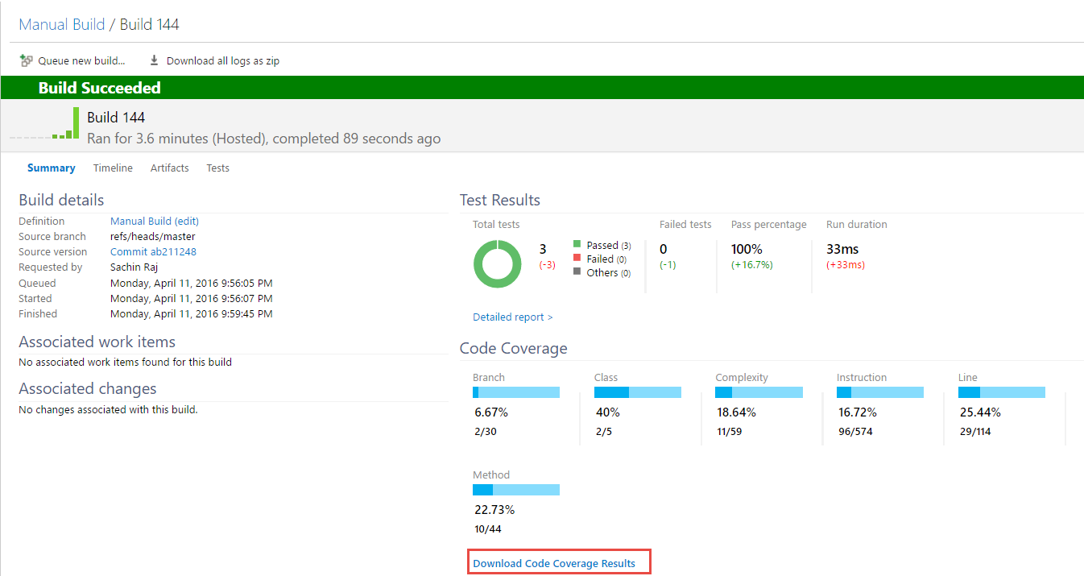

1. Save and extract the zip file to a local folder. Open the folder where you extracted the zip file and open the **index.html** file

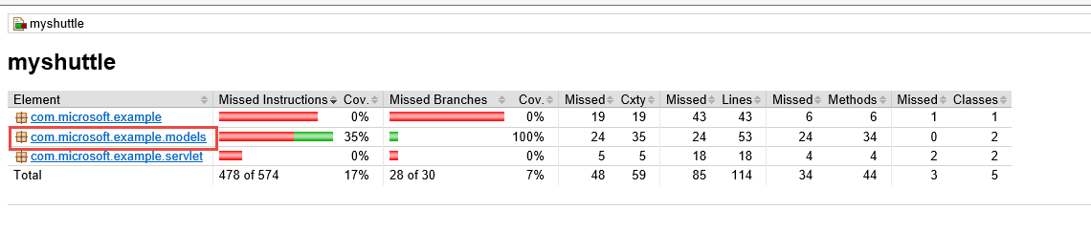

1. Select **com.microsoft.example.models** and then **Employee** and finally **getTotalFees(List)**. You will see the codes covered

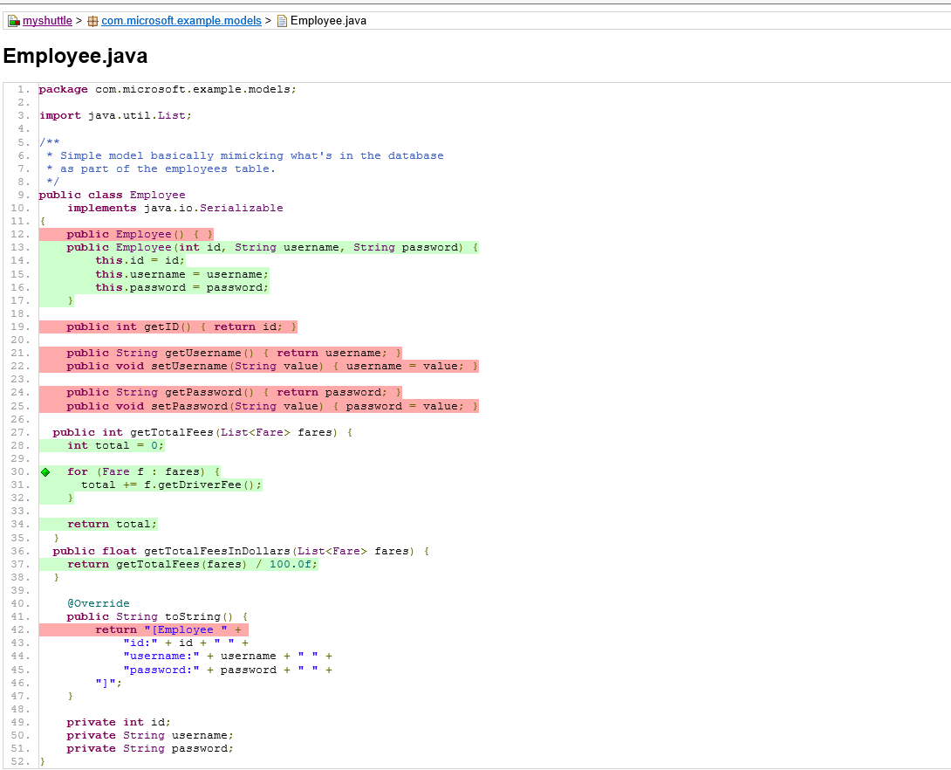

To give feedback please write to [devopsdemos@microsoft.com](mailto:devopsdemos@microsoft.com)

Copyright © 2016 by Microsoft Corporation. All rights reserved.